|  |  |
| --- | --- |
| cid:image004.png@01CF7F10.A4275880 | LOGO4 |
| Best Buy Canada Mobile | |
| |  | | --- | | **Modify Transaction Feature Document** |   **Document Version: 1.3**  **Revision Date: April 01, 2015** | |
| **Prepared By: Amy Byers** | |
|  | |

**Table of Contents**

*1.**Feature Overview* 3

1.1 Feature Description 3

1.2 Assumptions 3

1.3 Parameters and System Settings 3

1.4 Interfaces 4

*2.**USE CASE: Modify Transaction* 4

2.1 Feature Flow 4

2.2 Precondition 5

2.3 Main Flow 5

2.4 Alternate Flows 5

2.5 Post Condition 6

2.6 Special Requirements 6

*3.**Supplemental Specifications* 7

3.1 Electronic Journal 7

3.2 Manager Override 7

3.3 POSLog 7

3.4 Printed Receipts 8

*4.**Screen Layouts* 8

4.1 Modify Transaction 8

4.2 Enter Gift Receipt Quantity 12

*5.**Business Sign Off* 13

*6.**Revision History* 13

7. Appendix A: Source Documentation 13

7.1 Functional Requirements 13

*8.**Appendix* B*: Glossary* 14

# *Feature Overview*

## Feature Description

The Modify Transaction Feature Document describes the functionality of modifying transactions by editing the transaction at the transaction level.

## Assumptions

1. All text displayed by the system is configurable by brand to support multi-language.  Text is defined from an external source or defined within the system.

## Parameters and System Settings

| **Parameter Mnemonic** | **Description** | **Valid Values** |
| --- | --- | --- |
| Transaction Modify Menu Options | Determines what functionality is available in the transaction modify menu. | * Transaction Void * Kits on the Fly * Suspend * Reprint Last Tran Receipt * Reprint Last Tran Gift Receipt * Tax Override * Tax Exempt * Loyalty Lookup * Salesperson Capture * Gift Receipt * Transaction Transfer * Service Order Scheduling * Reprint Receipt * Capture Employee * Select Customer Language (see Select Customer Language Parameter) * Layaway Deposit * Pre-Order Deposit * Create Web Basket * Edit Web Basket * Import Web Basket * Remove Web Basket * IBH Override |
| Access Point Requires Manager Override | Determines the access point should check if it requires manager override. If disabled, then the system does not check for manager override requirements to perform the action.   * Reprint Last Transaction Gift Receipt * Reprint Las Transaction Receipt * Suspend * Transaction Void * Transaction Transfer * Reprint Receipt | * On * Off |
| Require Service Scheduling | Determines if the system checks the schedulable item attribute when an item is sold through Item Entry. If an item has the Schedulable Item Attribute enabled and the item is sold through Item Entry, the system checks if manager approval is required in order to continue. | * On * Off |
| Schedulable Item Attribute | Item attribute that defines a schedulable item. This item attribute is used if the Require Service Scheduling parameter is enabled. | * On * Off |
| Select Customer Language Parameter | The parameter that enables the customer to select which language is presented to them during the acceptance of terms and conditions, signature capture, tender authorization prompts on MPM device and receipt – by default the customer language is the store language. If the parameter for the customer to change their language is disabled or not present, the customer facing activities and printouts are in the stores language. | * On * Off |
| IBH Override | Determines if IBH Override is available for device | * On * Off |

## Interfaces

|  |  |
| --- | --- |
| **Interface** | **Description** |
| None |  |

# *USE CASE: Modify Transaction*

## Feature Flow



## Precondition

* The operator has selected to modify the transaction.
* Only features eligible on the transaction are displayed.

## Main Flow

1. The system displays the transaction modification options and prompts the operator to select an option.
2. If the operator selects to void the current transaction, the Transaction Void use case is executed.
3. If the operator selects to suspend a transaction, the Suspend use case is executed.
4. If the operator selects to print a transaction gift receipt, the Transaction Gift Receipt alternate flow is executed.
5. If the operator selects to tax override the transaction, the Tax Override use case is executed.
6. If the operator selects to tax exempt the transaction, the Tax Exempt use case is executed.
7. If the operator selects to capture salesperson at the transaction level, the Salesperson Capture use case is executed.
8. If the operator selects to create a kit on the fly, the Kits on the Fly use case is executed.
9. If the operator selects to search for Loyalty information, the Loyalty Usage use case is executed.
10. If the operator selects to check inventory on an item, the Inventory Lookup use case is executed.
11. If the operator selects to reprint the receipt of the last transaction on the device, the Reprint Last Tran Receipt use case is executed.
12. If the operator selects to reprint the gift receipt of the last transaction on the device, the Reprint Last Tran Gift Receipt use case is executed.
13. If the operator selects to schedule a service order, the Service Order Scheduling use case is executed.
14. If the operator selects to transfer the transaction, the Transaction Transfer use case is executed.
15. If the operator selects to reprint a receipt, the Reprint Receipt use case is executed.
16. If the operator selects to capture an employee for the transaction, the Employee Sale use case is executed.
17. If the operator selects to capture the customers preferred language for the transaction, the Select Customer Language use case is executed.
18. If the operator selects to override the IBH, the Override IBH Use case is executed.
19. If the operator selects to create a layaway deposit transaction type, the Layaway Deposit use case is executed.
20. If the operator selects to create a pre-order deposit transaction type, the Pre-Order Deposit use case is executed.
21. If the operator selects to update customer information, the Customer use case is executed.
22. If the operator selects to create a web basket, the Create Web Basket use case is executed.
23. If the operator selects to create a web basket, the Edit Web Basket use case is executed.
24. If the operator selects to create a web basket, the Import Web Basket use case is executed.
25. If the operator selects to create a web basket, the Remove Web Basket use case is executed.
26. If at any time the operator selects to return to the previous screen, the use case ends and the system returns to the calling use case.

## Alternate Flows

### Transaction Gift Receipt

1. The system prompts for the number of Gift Receipts requested.
2. The operator enters the number and selects Continue.
3. The system returns to the calling use case.

## Post Condition

* The selected use case is executed.

## Special Requirements

1. If a gift card is sold in the transaction, the suspend feature is not displayed.
2. The Kits on the Fly feature is only displayed when there are kit eligible items in the transaction.
3. Update Customer Info, Salesperson Capture, Tax Override, Tax Exempt, Inventory Lookup, Loyalty Lookup, and Service Order Scheduling are available prior to and after a transaction number being assigned to the transaction. **Note**: These are the available options, but further determination of what is displayed is based upon the transaction type and user must log in prior to displaying.
4. Transaction Void, Suspend, Kits on the Fly and Transaction Transfer are only available after a transaction number is assigned to the transaction. **Note**: These are the available options, but further determination of what is displayed is based upon the transaction type.
5. Layaway Deposit, Pre-Order Deposit, Reprint Receipt, Reprint Last Tran Receipt, Reprint Last Tran Gift Receipt and Select Customer Capture are only available prior to a transaction number being assigned to the transaction.
6. Service Order Scheduling is not available if there are non-scheduled Schedulable items in the transaction and the Require Service Scheduling parameter is enabled.
7. The menu options to be displayed are determined by the Transaction Modify Menu Options parameter.
8. The system checks if the following access points require manager approval before the action can begin. If enabled, the Manager Override use case is executed.

* Reprint Last Transaction Gift Receipt
* Reprint Last Transaction Receipt
* Suspend
* Transaction Void
* Transaction Transfer
* Reprint Receipt

1. Kits on the Fly is not available when the transaction is an employee transaction.
2. If a Kit exists in the transaction and the transaction is changed to be an employee transaction, the kit is deleted from the transaction.
3. . The ability to perform the capturing of the customers language is based upon the Select Customer Language parameter. If the parameter is disabled, the option is not present in the Transaction Modify Menu – if the parameter is enabled, the option is present in the Transaction Modify Menu
4. The following table represents when the Create Web Basket, Edit Web Basket, Import Web Basket and Remove Web Basket are to be displayed:

|  | Trans Type | MCF-Create Basket | MCF-Edit Basket | MCF-Import Basket | MCF-Remove Basket |
| --- | --- | --- | --- | --- | --- |
|  | Sale | Available only if there is no MCF Sale items imported in the transaction | Available | Available | Available only when there is an MCF Sale item imported in the transaction. |
|  | Return | Not Available | Not Available | Not Available | Not Available |
|  | Exchange – Sale Side | Available only if there is no MCF Cancel Line Items on the return side and if there is no MCF Sale items imported in the transaction | Available only if there is no MCF Cancel Line Items (Return) on the return side | Available only if there is no MCF Cancel Line Items (Return) on the return side | Available only if there is no MCF Cancel Line Items on the return side and when there is an MCF Sale item imported in the transaction |
|  | SIE – PSP Fulfillment, MFG Warranty, Service Exception | **Return** – Not Available  **Sale** – Available only if there is no MCF Cancel Line Item on the return side | **Return** – Not Available  **Sale** – Available only if there is no MCF Cancel Line Item on the return side | **Return** – Not Available  **Sale** – Available only if there is no MCF Cancel Line Item on the return side | **Return** – Not Available  **Sale** – Available only if there is no MCF Cancel Line Item on the return side and MCF Order has been imported on the sale side |
|  | Lost and Damaged | **Return** – Not Available  **Sale** – Available only if there is no MCF Cancel Line Item on the return side | **Return** – Not Available  **Sale** – Available only if there is no MCF Cancel Line Item on the return side | **Return** – Not Available  **Sale** – Available only if there is no MCF Cancel Line Item on the return side | **Return** – Not Available  **Sale** – Available only if there is no MCF Cancel Line Item on the return side and MCF Order has been imported on the sale side |
|  | Adjustment – Price Match, Price Correction | Not Available | Not Available | Not Available | Not Available |
|  | Account Refund | Not Available | Not Available | Not Available | Not Available |
|  | Payment On Account | Not Available | Not Available | Not Available | Not Available |
|  | Layaway Deposit | Not Available | Not Available | Not Available | Not Available |
|  | Pre-Order Deposit | Not Available | Not Available | Not Available | Not Available |
|  | Cash In/Out | Not Available | Not Available | Not Available | Not Available |
|  | Training Mode | Not Available | Not Available | Not Available | Not Available |
|  | Employee | Same process as non-employee transaction | Same process as non-employee transaction | Same process as non-employee transaction | Same process as non-employee transaction |

### Special Offline Requirements

TBD

### Data Input/Output

|  |  |  |
| --- | --- | --- |
| **Data Element** | **Description** | **Destination** |
| None |  |  |

# *Supplemental Specifications*

## Electronic Journal

Electronic journal mockups for this feature are documented in the Electronic Journal document.

## Manager Override

The Manager Override feature is called when one of the options is selected and require manager override:

* Reprint Last Transaction Gift Receipt
* Reprint Last Transaction Receipt
* Suspend
* Transaction Void
* Transaction Transfer
* Reprint Receipt
* Update Customer prior to transaction number assigned.

## POSLog

POSLog mockups for this feature are documented in the POSLog document.

## Printed Receipts

Printed receipt mockups, where applicable, are documented in the Receipt Generation document.

# *Screen Layouts*

## Modify Transaction

This screen is displayed when the operator selects modify the transaction. The screen prompts the operator to select a transaction level modification.

The menu options to be displayed are determined by the Transaction Modify Menu Options parameter.

### Mockup

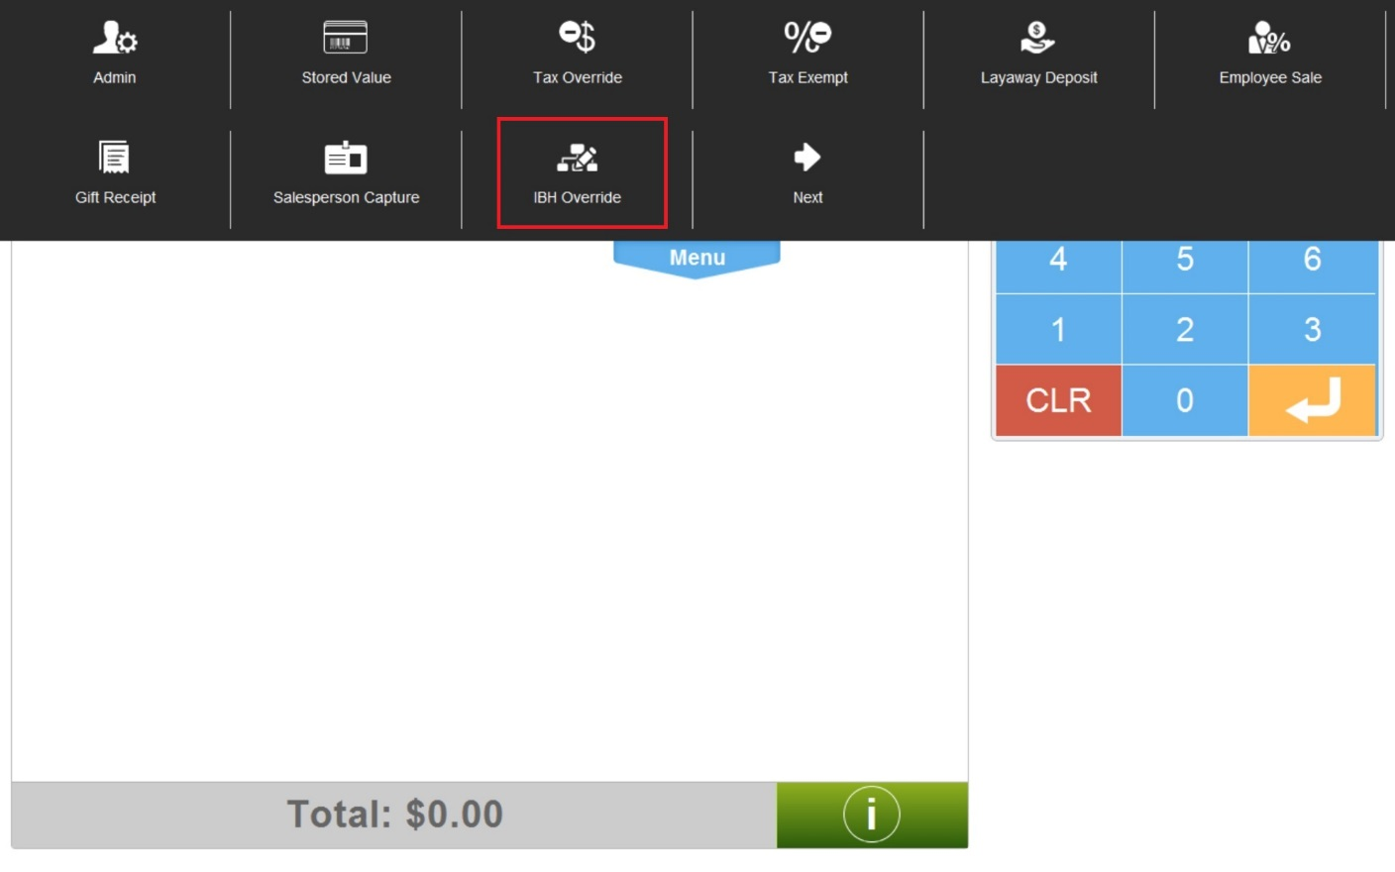

Figure 1: Modify Transaction

### Instruction Text

|  |
| --- |
| **Instructions** |
| None |

### Navigation/Menu Keys – Initial Login and Sale Transaction Type

| **Label** | **State** | **Next Screen** | **Notes** |
| --- | --- | --- | --- |
| Gift Receipt | Enabled | Modify Transaction use case | A visual indicator on the transaction marked for gift receipt |
| Kits on the Fly | See Notes | Kits on the Fly use case | Disabled if no items in the transaction have the Kit Eligible attribute. |
| Salesperson Capture | Enabled | Salesperson Capture use case | None |
| Suspend | See Notes | Suspend use case | * Disabled: Transaction number has not been assigned * Disabled: Transaction number assigned and Gift Card Issued Item in the transaction. * Enabled: Transaction number has been assigned   Check if Manager Override is required before starting the action. |
| Tax Override | Enabled | Tax Override use case | None |
| Tax Exempt | Enabled | Tax Exempt use case | None |
| Transaction Void | See Notes | Transaction Void use case | * Disabled: Transaction number has not been assigned * Enabled: Transaction number has been assigned   Check if Manager Override is required before starting the action. |
| Loyalty Lookup | Enabled | Loyalty Usage use case | None |
| Inventory Lookup | Enabled | Inventory Lookup use case | None |
| Reprint Last Tran Receipt | See Notes | Reprint Last Tran Receipt use case | * Disabled: Transaction number has been assigned (transaction started) * Enabled: Transaction number has not been assigned   Check if Manager Override is required before starting the action. |
| Reprint Last Tran Gift Receipt | See Notes | Reprint Last Tran Gift Receipt use case | * Disabled: Transaction number has been assigned (transaction started) * Enabled: Transaction number has not been assigned   Check if Manager Override is required before starting the action. |
| Reprint Receipt | See Notes | Reprint Receipt use case | * Disabled: Transaction number has been assigned (transaction started) * Enabled: Transaction number has not been assigned   Check if Manager Override is required before starting the action. |
| Transaction Transfer | See Notes | Transaction Transfer use case | * Disabled: Transaction number has not been assigned * Disabled: Transaction number assigned and Gift Card Issued Item in the transaction. * Enabled: Transaction number has been assigned   Check if Manager Override is required before starting the action. |
| Service Order Scheduling | See Notes | Service Order Scheduling use case | * Disabled: A schedulable item (item attribute) is sold through the Sale use case and is not scheduled. This is only the case if the parameter for Require Service Schedule is enabled. * Enabled: Before and after a transaction number has been assigned to the transaction. |
| Capture Employee | Enabled | Employee Sale use case | * Disabled: If at least one item in the transaction has a Raincheck issued then option to switch to Employee is disabled. * Enabled: Any Sale Transaction Type where there are not Rainchecks Issued in the transaction. |
| Select Customer Language | See notes | Select Customer Language use case | * Disabled: If the Select Customer Capture parameter is disabled and if the transaction has already begun. * Enabled: If the Select Customer Capture parameter is enabled and the transaction has not already begun. |
| Layaway Deposit  (Transaction Type) | See Notes | Layaway Deposit use | * Disabled: Transaction number has been assigned * Enabled: Transaction number has not been assigned |
| Pre-Order Deposit  (Transaction Type) | See Notes | Pre-Order Deposit use case | * Disabled: Transaction number has been assigned * Enabled: Transaction number has not been assigned |
| Update Customer Info | See Notes | Customer use case | None |
| Create Web Basket | See Notes | Create Web Basket use case | See Available MCF Menu Options |
| Edit Web Basket | See Notes | Edit Web Basket use case | See Available MCF Menu Options |
| Import Web Basket | See Notes | Import Web Basket use case | See Available MCF Menu Options |
| Remove Web Basket | See Notes | Remove Web Basket use case | See Available MCF Menu Options |
| IBH Override | Enabled | Override IBH Use Case |  |

### Navigation/Menu Keys – Other Transaction Types

| **Transaction Type** | **Available Modify Transaction Menu** | **Not Available Modify Transaction Menu** |
| --- | --- | --- |
| Layaway Deposit | * Sales Person Capture * Transaction Void * Suspend * Transaction Transfer * Tax Override * Tax Exempt * Kits on the Fly * Loyalty Lookup | * Employee * Transaction Gift Receipt * GRID/WFMS – Service Order Scheduling * Inventory Lookup * Receipt Reprint Options * Pre-Order Deposit * Select Customer Language |
| Pre-Order Deposit | * Sales Person Capture * Transaction Void * Suspend * Transaction Transfer * Loyalty Lookup | * Tax Override * Tax Exempt * Kits on the Fly * Employee * Transaction Gift Receipt * GRID/WFMS – Service Order Scheduling * Inventory Lookup * Receipt Reprint Options * Pre-Order Deposit * Select Customer Language |

### Available MCF Menu Options

|  | Trans Type | MCF-Create Basket | MCF-Edit Basket | MCF-Import Basket | MCF-Remove Basket |
| --- | --- | --- | --- | --- | --- |
|  | Sale | Available only if there is no MCF Sale items imported in the transaction | Available | Available | Available only when there is an MCF Sale item imported in the transaction. |
|  | Return | Not Available | Not Available | Not Available | Not Available |
|  | Exchange – Sale Side | Available only if there is no MCF Cancel Line Items on the return side and if there is no MCF Sale items imported in the transaction | Available only if there is no MCF Cancel Line Items (Return) on the return side | Available only if there is no MCF Cancel Line Items (Return) on the return side | Available only if there is no MCF Cancel Line Items on the return side and when there is an MCF Sale item imported in the transaction |
|  | SIE – PSP Fulfillment, MFG Warranty, Service Exception | **Return** – Not Available  **Sale** – Available only if there is no MCF Cancel Line Item on the return side | **Return** – Not Available  **Sale** – Available only if there is no MCF Cancel Line Item on the return side | **Return** – Not Available  **Sale** – Available only if there is no MCF Cancel Line Item on the return side | **Return** – Not Available  **Sale** – Available only if there is no MCF Cancel Line Item on the return side and MCF Order has been imported on the sale side |
|  | Lost and Damaged | **Return** – Not Available  **Sale** – Available only if there is no MCF Cancel Line Item on the return side | **Return** – Not Available  **Sale** – Available only if there is no MCF Cancel Line Item on the return side | **Return** – Not Available  **Sale** – Available only if there is no MCF Cancel Line Item on the return side | **Return** – Not Available  **Sale** – Available only if there is no MCF Cancel Line Item on the return side and MCF Order has been imported on the sale side |
|  | Adjustment – Price Match, Price Correction | Not Available | Not Available | Not Available | Not Available |
|  | Account Refund | Not Available | Not Available | Not Available | Not Available |
|  | Payment On Account | Not Available | Not Available | Not Available | Not Available |
|  | Layaway Deposit | Not Available | Not Available | Not Available | Not Available |
|  | Pre-Order Deposit | Not Available | Not Available | Not Available | Not Available |
|  | Cash In/Out | Not Available | Not Available | Not Available | Not Available |
|  | Training Mode | Not Available | Not Available | Not Available | Not Available |
|  | Employee | Same process as non-employee transaction | Same process as non-employee transaction | Same process as non-employee transaction | Same process as non-employee transaction |

### Data/Input Fields

|  |  |  |  |  |  |  |
| --- | --- | --- | --- | --- | --- | --- |
| **Label** | **Editable** | **Req’d?** | **Data Type** | **Min**  **Length** | **Max**  **Length** | **Notes** |
| None |  |  |  |  |  |  |

### Reason Codes

|  |  |  |
| --- | --- | --- |
| **Reason Code** | **Valid Values** | **Default Value** |
| None |  |  |

## Enter Gift Receipt Quantity

This pop over is displayed when the Gift Receipt Transaction Modify is selected and prompts the operator to enter the number of gift receipts to print.

### Mockup

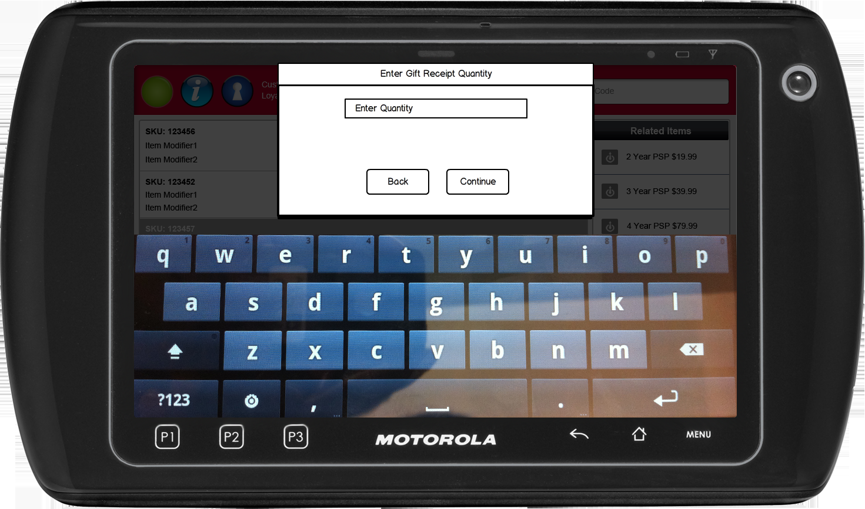

Figure : Enter Gift Receipt Quantity

### Instruction Text Enhancements

|  |
| --- |
| **Instructions** |
| None |

### Navigation/Menu Key Enhancements

|  |  |  |  |
| --- | --- | --- | --- |
| **Label** | **State** | **Next Screen** | **Notes** |
| Back | Enabled | Sale use case | None |

### Data/Input Field Enhancements

|  |  |  |  |  |  |  |
| --- | --- | --- | --- | --- | --- | --- |
| **Label** | **Editable** | **Req’d?** | **Data Type** | **Min**  **Length** | **Max**  **Length** | **Notes** |
| Enter Quantity | Yes | Yes | Numeric | 1 | 10 | None |

### Reason Code Enhancements

|  |  |  |
| --- | --- | --- |
| **Reason Code** | **Valid Values** | **Default Value** |
| None |  |  |

# *Business Sign Off*

|  |  |  |
| --- | --- | --- |
| **Name** | **Organization** | **Date** |
|  |  |  |

# *Revision History*

|  |  |  |  |
| --- | --- | --- | --- |
| **Reviser** | **Revision** | **Date** | **Version** |
| Amy Lackas | Initial document created. This version includes the following changes: Layaway Deposit, Pre-Order Deposit, Update Customer Information, Raincheck. | 10/28/2013 | 1.0 |
| Amy Lackas | Updates to add new features: MCF | 11/01/2013 | 1.1 |
| Amy Byers | * Section 2.6: Added clarification that user must be logged in to update a customer. * Section 3.2: Update customer outside a transaction can be configured to require manager approval. * Section 7: Added requirement matrix | 10/6/2014 | 1.2 |
| Amy Byers | Updates to add IBH Override feature | 4/1/2015 | 1.3 |

# Appendix : Source Documentation

* Requirement Specification - XPOS.xlsx

## Functional Requirements

| **ID** | **Sub Category** | **Description** | **Section(s)** |
| --- | --- | --- | --- |
| 2.13 | Customer Capture | A user will be able to update a Customer record outside of a transaction. | * 2.6 Special Requirements |
| 2.14 | Customer Capture | A user must be logged into the XPOS application in order to access the Update Customer function. | * 2.6 Special Requirements |
| 2.15 | Customer Capture | Manager Approval will be configurable to be required or not required, when attempting to update a customer record outside of a transaction. | * 3.2 Manager Override |
| 2.16 | Customer Capture | The Update Customer function will utilize the existing Customer Capture process flow. | * 2.3 Main Flow |

# *Appendix : Glossary*

| **Term** | **Definition** |
| --- | --- |
| UPC | Universal Product Code |
| Open Box Item | Items that are returned open and functional. The product can then be re-sold as an open box item. |
| Open Box Tag | The 9-character value associated with the open box item. The entry of this value in Item Entry triggers the Open Box Item use case. An open box tag is associated with one item, but an item can be associated with multiple open box tags. Also called License Plate # (LP#) |
| Register Number | A register Number is not the unique device ID, but is the 1-2 digit ID assigned to the device to be used in the creation of the Transaction Key and logged in the POSLog, EJ, and on the Receipt. There can be multiple devices associated with one register Number. |
| Device ID | A unique identification associated with the device. This ID is not logged in the POSLog, EJ or Receipt. |
| IBH | International Business Hierarchy |